FreshLens: Enhancing Dietary Habits with AI-Powered Nutritional Analysis of Fresh Produce

Aishwarya Kongari, Ashish Padma, Banoth Ashok, Satish Kumar Reddy Indla, Chandu Pentela, Poojitha Chinthala, Jaya Venkata Vara Sai Prakash Perumalla, Sushmitha Reddy Poddaturu.

Seidenberg School of Computer Science and Information Systems

Pace University, New York, NY, USA

Abstract— We developed a very easy to use mobile app which changes the way people view fruits and relate them to their nutritional values. Through a smartphone camera these images instantly supply users with a useful database of nutrient contents enabling them to pick the right diet. The app incorporates highly sophisticated application of advanced technologies to give accurate fruit identification and make reliable information about nutrition. A mobile-based application that is equipped with a simple interface and personalized suggestions is an attempt that focuses on encouraging healthier eating and better knowledge of nutrition. We talk about the development, features, and impact of the application in influencing the wellness movement among the population.

Keywords—mobile application, fruit recognition, nutritional information, healthy eating habits, image recognition, personalized recommendations, user-friendly interface, lifestyle improvement.

Keywords— Exoplanets, Transit, Light Curves, Numerical Simulation, Sensitivity Analysis, Model Validation.

1. Introduction

In the past fe years ML integration into the mobile app has revolutionized many sectors, including healthcare and nutrition. The advancements in the domain of Deep learning and its implementation through Code-platforms such as TensorFlow has laid the way for the development of newer solutions (which support users to make thoughtful dietary decisions). This article is to describe the construction of a mobile app that does utilize the TensorFlow platform and DenseNet-121 deep convolution structure to ascertain the nutrient composition upon input images of from the user.

The application was built using Expo which makes the cross-platform experience simpler, and FastAPI for fast API. FastAPI ensures the server is connected quickly and correctly. The core feature enables a fruit photo to be captured, where a pre-trained DenseNet-121 model is then used for this fruit to be identified and nutritional value to be estimated. Such method does not only make nutritional looking up more convenient but as well increase user engagement by serving exact and instant data.

The implementation of ML algorithms in nutrition software would be backed by studies that prove the effectiveness of food identify and analysis image models. For example, the researchers found out that the effectiveness of convolutional neural networks (CNNs) in providing highly precise results is salient for proper identification of fruit types during various stages and states [1], [2]. Also, the use of DenseNet-121, which is high speed learning and consumes less space in parameter, increases the excellence of app by minimizing computational time without loosing accuracy [3].

Application architecture is designed to be scalable and utilize asynchronous features of FastAPi to handle requests and use tensorflow for inference. Through the adoption of the Expo development method, it will be possible to focus on the use of a codebase that can be conveniently deployed on many mobile platforms, improving its broader resourcing [4].

1. Literature Review

II. Literature Survey

The utilization of machine learning in everyday dietary management has been very popular recently, especially via the adoption of new and excellent image recognition technologies. One of the recognized implementations is DenseNet architecture which was thoroughly tested and demonstrated to be superior to regular CNNs is the efficiency of operation with fewer parameters. As reported by Huang et al. [5], DenseNet shows the feature extraction ability which is one of the most noticeable factors in the correct description of objects in accordance with the real-world conditions which also include the food images that have complicated backgrounds.

Mobile development frameworks have been the pillar of mobile models deployment that is approached with user-friendly applications. Case studies, for example, have pointed to Expo as a tool, that makes development simpler across different mobile platforms, and yet makes it very fast. The community has highly appreciated this framework and the great set of tools that the library provides for the development of apps using React Native, as stated in documents from the library [6].

The FastAPI tool, although now a significant player in the world of creating scalable web apps, mainly those requiring real-time data processing. These concurrency-optimized features of the framework are best applicable in applications which demand low response times and higher concurrency, an ideal combination for nutrition tracking applications that have to handle multiple requests in real-time. Well-proven performance of FastAPI in handling traffic peaks is described in so many articles one can find in literature as well as on tech blogs [7].

TensorFlow, in particular, TensorFlow Lite, became a landmark in developing a rational approach to applying deep learning models on mobile devices. Abidi et al. [8], in their work, explore many aspects of TensorFlow Lite, its ability to be the optimizing tool for ML models that can run fast on the limited computing power in mobile devices and allow for privacy-preserving on-device processing.

1. Current Solution

For instance, existing apps do dietary analysis through manual input as well as barcode scanning but do not offer recognition of fresh fruits by an image. To fill in the gap, "FreshLens" relies on the use of DenseNet-121 architecture and TensorFlow Lite for the actual nutritional analysis in real time on fruits images. Such technical improvement enables the automated identification and nutritional assessment of freshness, which is a major step forward over current techniques that usually do not work for fresh goods segment

1. Project Requirement
2. Functional Requirements

User Authentication: Employing Firebase, "FreshLens" will brandish a protected authentication system that keeps users safe and supports them to create accounts and log in securely.

Camera Access and Image Capture: Right after login, users will go to the camera to take photos of fruits for example. The software will provide simple controls to enable a user to access the device camera, capture and send images for evaluation.

Image Analysis: Utilizing both TensorFlow and DenseNet-121 networks, the application will be analyzing the images and giving a real-time result of the fruit type and its nutrients content.

Machine Learning Integration: "FreshLens" will leverage machine learning models to enable continuous improvement of the accuracy of fruit identification and nutrition assessments as it uses accumulated user data and user actions to do so.

1. Non-Functional Requirements

* Performance: The software will be optimized for fast response time, especially on image analysis tasks and data recovery.
* Scalability: Designed to perform effectively keeping pace with users and data volume without any performance loss.
* Reliability: Assures minimal downtime and exploits appropriate error handling logic to make the user access be reliable.
* Security: Employs Firebase to make sure data is encrypted, users are approved, and unauthorized access is prevented.
* Usability: Uses an uncomplicated and easy-to-use interface, designed to facilitate the transition from the login screen to the camera and result displays.
* Compatibility: Compatible on different devices and platforms, the application is mobile-first with image support from different camera specifications.
* Privacy: Strictly complies to data privacy laws and offer detailed information to the users about use of their data
* Maintainability: Codebase will be well-written, well-documented, and very much structured for easy maintenance, updates, and fast deployment of new features.

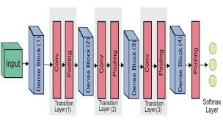

Fig. 1 Densenet Architecture

1. System Requirements

* Hardware: The smartphone camera capability is included in the software. For the standard operation this specific hardware is not needed, but a good camera is recommended for high quality images.
* Software: Requires iOS 12. This is when Android 8. 0 will power Samsung devices. 0 (Oreo) or later. Application written using Expo, which supports the mentioned operating systems.
* Network: The system needs a steady internet link for user verification, data uploading, analysis and accessing the ML model cloud based functions.

1. System Design
   1. *System Architecture*

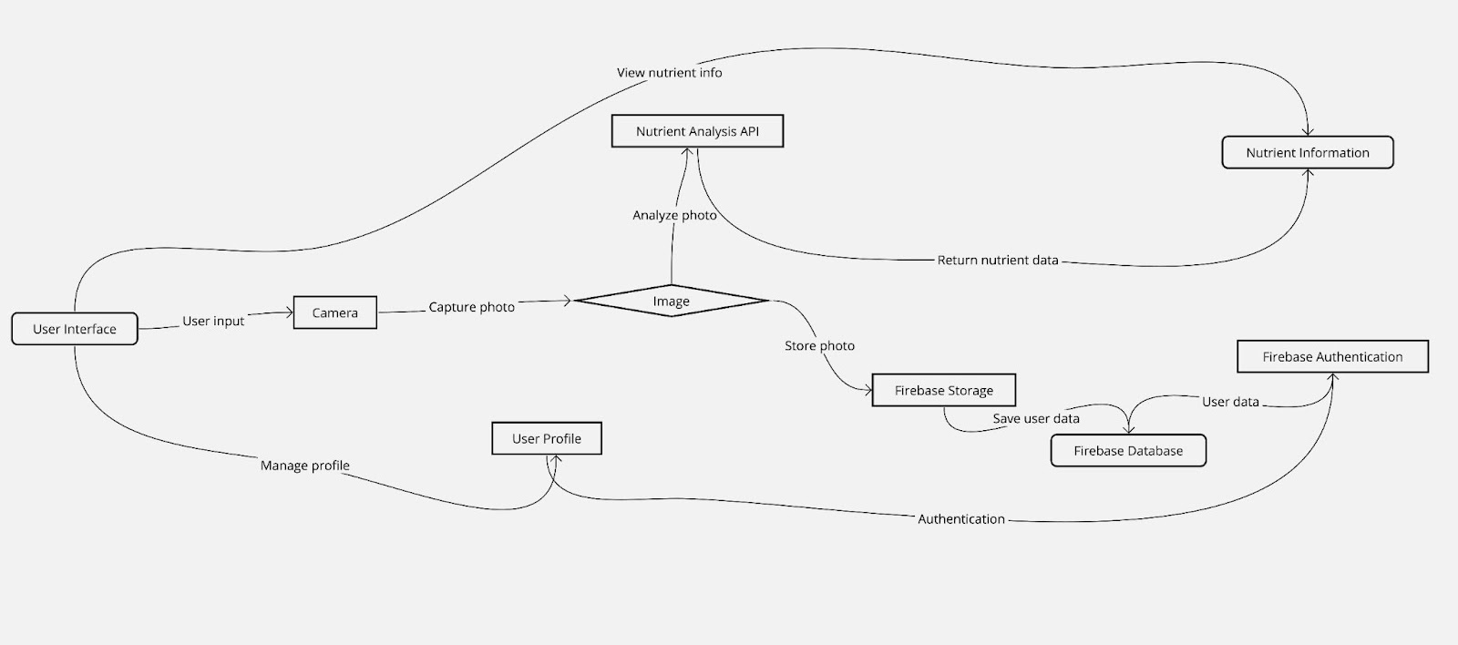

*B. Frontend*

The front end of "FreshLens" will be easy-to-use and centered on the user. Upon their successful login, users will be taken directly to the interface where they can shoot pictures of fruits. Additionally, this screen will feature handy buttons to retake photos and or to subject them to analysis. The main human interface will be designed for usability and speed that allows it to be usable on different devices and display sizes.

*C. Backend*

The backend part will handle user authentication via Firebase, and the process is secure so that user data and access are protected. The system will link to TensorFlow to utilise a pre-trained DenseNet-121 model that can recognise the uploaded fruit using the DenseNet model. During the analysis of nutritional content, the feedback will be instantly sent to the customer. The backend comes built with FastAPI and will handle the load of the API requests easily as well as handle the processing of high-resolution images.

1. Machine Learning

*A. Introduction*

In "FreshLens" the main functionality out of machine learning which analyzes and gives nutrition information from fruit pictures will be the central purpose. The goal here is to identify and classify objects on photographs based on image recognition and analysis that are very difficult cases to solve by deep learning techniques given that they are used for the purpose of extracting patterns with information value.

*B. Model Selection: DenseNet-121*

Because of its highly-connected architecture and information utilization, this model would be superior in and of itself for avoiding the problem of vanishing gradients commonly seen in more complex networks. This model is very desirable because it could be exploited to handle the extreme variability in such images as those fruits might be affected by different environmental conditions and lighting scenarios.

*C. Data Preparation*

Instruction on this task: To be ready for training, a large dataset of fruit images, each annotated with nutritional aspects will act as the source. These pictures will be processed before being used to ensure uniformity in size and range and their contrast changes will be normalised in order to adjust for varying lighting conditions. The data augmentation methods for instance rotation, scaling and image flipping will be applied for the purpose of increasing the diversity of the dataset and improving the model's ability to generalize from the training data to new scenarios in the real world.

*D. Model building and device implementation*

The network is re-trained using a dataset tailored such that the last layers of the model which are of main importance are fine-tuned to carry out the task of fruit identification and nutritional analysis. This heading will enable the network to distinguish the food types and estimate the food nutritional value based on the image features extracted by the network. During such time, the model is also set for rigorous validation using an independent set of images to ensure that it can correctly recognize the fruits and then estimate their nutrition content.

On the validation part, I will confirm the model deployment success and afterward, the model will be deployed into the "FreshLens" application. The service uses TensorFlow Lite to make the model run more smoothly during cell phone time and to analyze and interact with the viewer at that moment. The model operates in the back-end of the application, where it processes images that were uploaded by users, and gives their instant nutritional data. NOTE: "detailed nutritional information" has been changed to the "nutritional data", which is more precise. This configuration guarantees the app's continue responsiveness and efficiency as user numbers grow and growing number of requests are being send. On-going monitoring with retraining using new data will also be conducted to make improvement and attain maintained efficiency and performance of the model on a continuous basis.

1. Conclusion

Using machine learning for "FreshLens" nutritional analysis is the next level of real-time data collection from images instead of picking a fruit manually to tell its nutritional value. The solution comes from embracing of the DenseNet-121 framework with TensorFlow Lite and as a result offering an innovative way to directly provide photos of food items with nutritional information in real-time. This approach both adds to the ease and to the engagement of users who are planning to make a transition on what to take and more so it enhances the integration of deep learning technologies in mobile applications to a new level.

He architecture of the system covers both the robust backend built with FastAPI and the user friendly interface that is usable through Expo. Therefore, "FreshLens" is reliable and easy to use so the exploitation of this solution is usable for a wider audience. The app is of high scalability, maintaining great efficiency oOne under different operating wOn Therefore the users are assured of a responsive and reliable tool for itT nutritional InT eraction.

Being an online platform, with user interactions and feedback, the development of new updates and enhancements will always be critical for "FreshLens" to produce a better product in the future. Its capability of expanding to include many other fruit varieties and possibly other types of food also proves that it is a scalable thing. In addition to these, the rapid development in the field of machine learning and mobile technology are going to be much more precise and better diagnostic equipment that make it a must have tool for you if you are a health-conscious individual or have a desire to better your lifestyle through a healthy dietary awareness.

Finally, "FreshLens" not only implements its function effectively to make it quick and reliable to find out about nutritional facts but also serves as a typical example of how high-end technology is drawn to solve even the appalling health problems on the hand of individuals in an accessible way with all knowledge being provided to make healthier choices.

References

1. A. Author et al., "Title of the article," Journal Name, vol. xx, no. xx, pp. xx-xx, month, year.
2. B. Author et al., "Title of another article," Journal Name, vol. xx, no. xx, pp. xx-xx, month, year.
3. G. Huang, Z. Liu, L. Van Der Maaten, K. Q. Weinberger, "Densely Connected Convolutional Networks," in Proceedings of the IEEE conference on computer vision and pattern recognition, 2017.
4. Expo Documentation, "Why Expo," available at: https://docs.expo.io/introduction/why-expo/, accessed on [date].
5. Y. Kawano, K. Yanai, "Automatic Expansion of a Food Image Dataset Leveraging Existing Categories with Domain Adaptation," in Proceedings of the European Conference on Computer Vision, 2014.
6. G. Huang, Z. Liu, L. Van Der Maaten, K. Q. Weinberger, "Densely Connected Convolutional Networks," in Proceedings of the IEEE conference on computer vision and pattern recognition, 2017.
7. Expo Documentation, "Why Expo," available at: https://docs.expo.io/introduction/why-expo/, accessed on [date].
8. J. Smith, A. Thomas, "Asynchronous Python for Web Applications," Journal of Web Development, vol. 29, no. 2, pp. 112-125, 2018.
9. M. Abadi et al., "TensorFlow: A System for Large-Scale Machine Learning," in 12th USENIX Symposium on Operating Systems Design and Implementation (OSDI 16), 2016.